SQL Murder Mystery Project
The code was done on https://mystery.knightlab.com/
A crime has taken place and the detective needs your help. The detective gave you the crime scene report, but you somehow lost it. You vaguely remember that the crime was a ​murder​ that occurred sometime on ​Jan.15, 2018​ and that it took place in ​SQL City​. Start by retrieving the corresponding crime scene report from the police department’s database.

Exploring the Database Structure
Experienced SQL users can often use database queries to infer the structure of a database. But each database system has different ways of managing this information. The SQL Murder Mystery is built using SQLite. Use this SQL command to find the tables in the Murder Mystery database.
Run this query to find the names of the tables in this database.
This command is specific to SQLite. For other databases, you'll have to learn their specific syntax.

SELECT name FROM sqlite_master WHERE type = 'table
Result of the above code
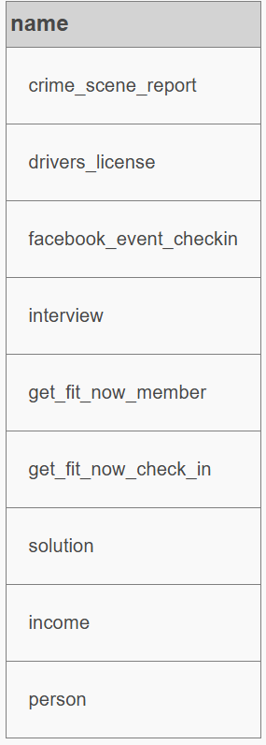
Besides knowing the table names, you need to know how each table is structured. The way this works is also dependent upon which database technology you use. Here's how you do it with SQLite.
Run this query to find the structure of the `crime_scene_report` table
Change the value of 'name' to see the structure of the other tables you learned about with the previous query.

SELECT sql FROM sqlite_master WHERE name = 'crime_scene_report'
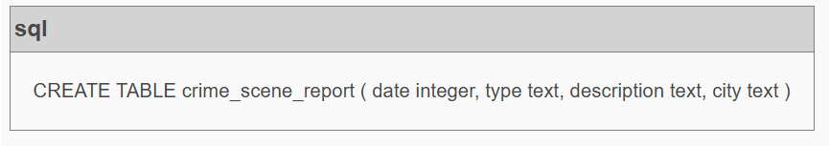
Schema Diagram that shows the relationship between the tables
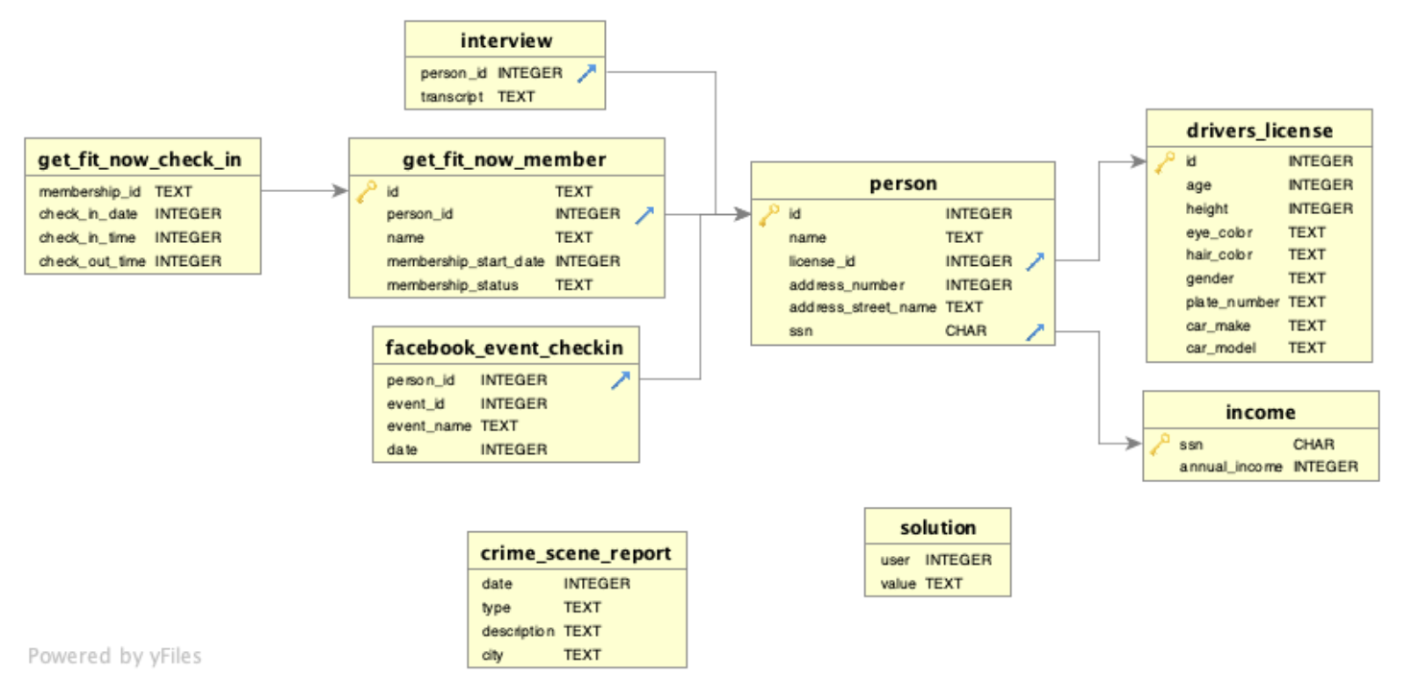
Blue arrows in the box indicate the foreign keys of that table – this is useful while joining the tables and the Key images shown next to the id column in the Person table, get_fit_now_member, drivers_license, income are Primary key.

With the description given on the first paragraph of the above page, here is the SQL query
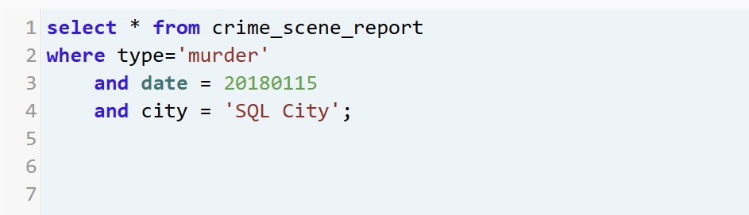

Result of this query is
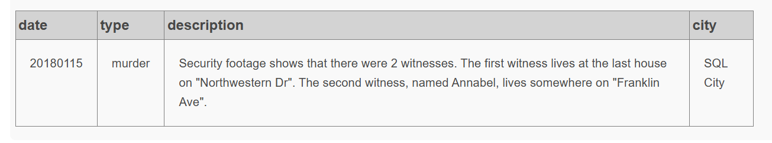
It says in the description column that the security footage shows 2 witnesses for this murder
Witness 1 – Lives at the last house on Northwestern Dr.
Witness 2 – named Annabel lives somewhere on Franklin Ave.

To locate the witnesses
Witness 1
The query result was a large set of data – Since we had descending on the order by (Order by sorts the “address_number” table in descending order) to locate the last house. We will take the first person from the database table because that is likely to be last house on Northwestern drive.
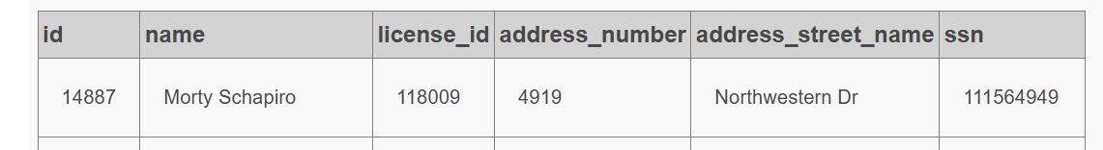
Witness 2
There was only one row with Annabel and Franklin Ave.
Result of the query is
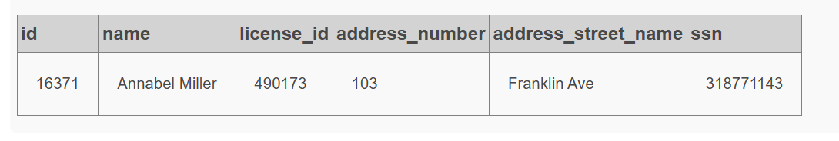
Both results have an id number – will use that to get the data from interview table
The id number of Witness 1 – 14887 (located on the person table)
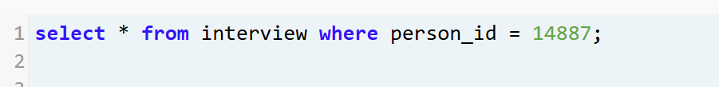
Result of the above query is
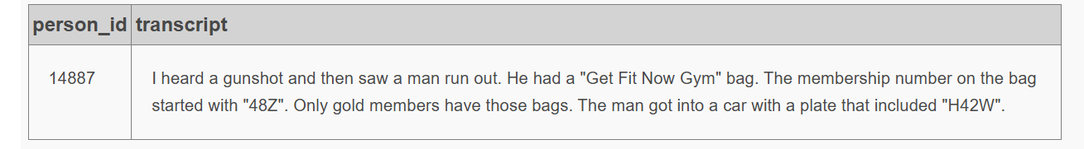

The id number from Witness 2
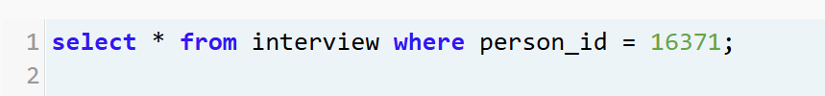
Result of the above query is
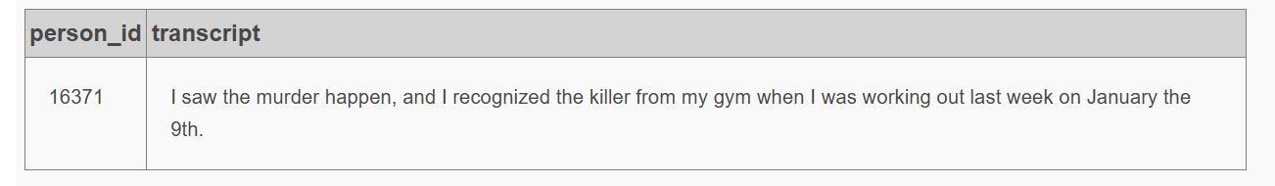

Based on the Witness 1 transcript, next query is
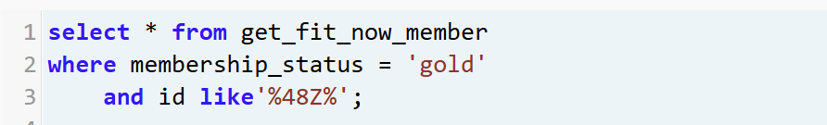
The result was
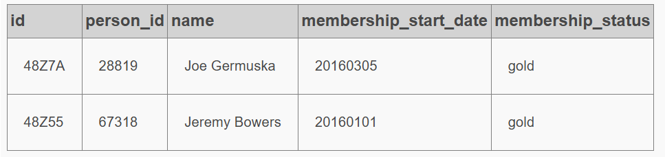

Based on the Witness 2 transcript, next query is
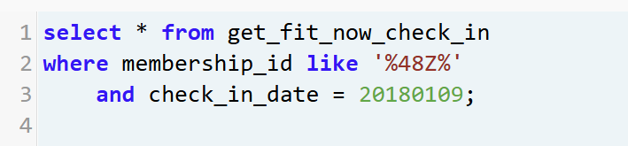
Result is
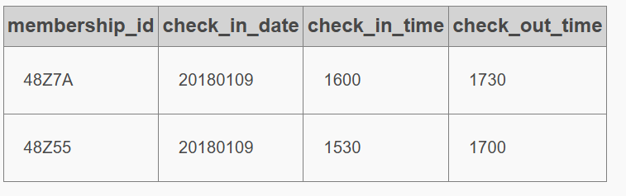

Based on the above two query results – the murder might be either Joe Germuska or Jeremy Bowers since they both queries are giving the name

Next query is based on the license plate mentioned by the witness 1

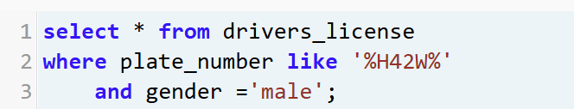
Result is
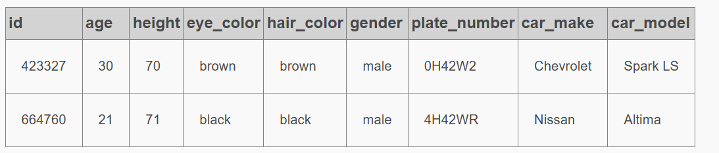
Based on the above filter – created a new query with license id to make sure we have the correct name – Result matched Jeremy Bowers
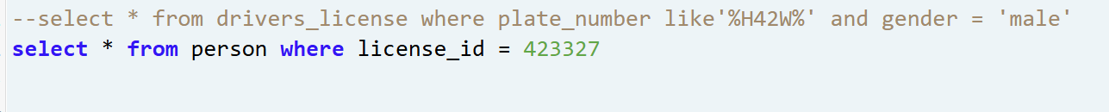
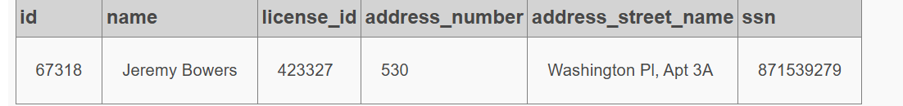
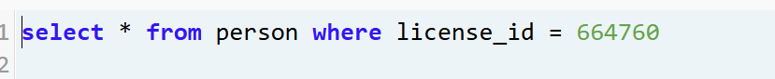
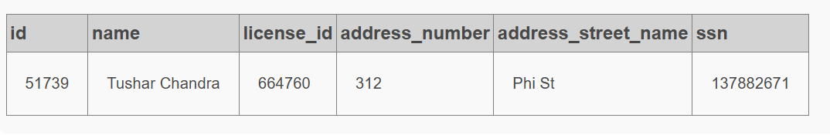
As we know that Jeremy Bowers have gym membership, Lets check Tushar Chandra has a membership at get_fit_now_member

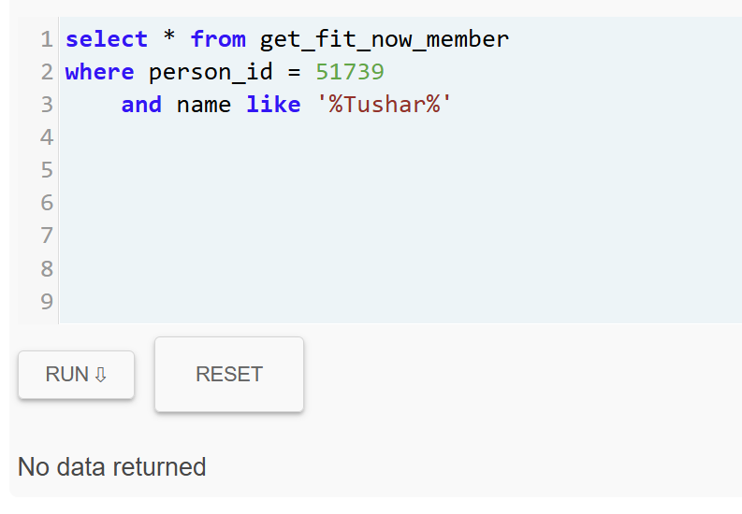
The result shows no gym membership for Tushar.
After comparing the license_id and the witness transcript and gym membership, everything finally leads to Jeremy Bowers name
Therefore, for final confirmation – narrow down – used the below query
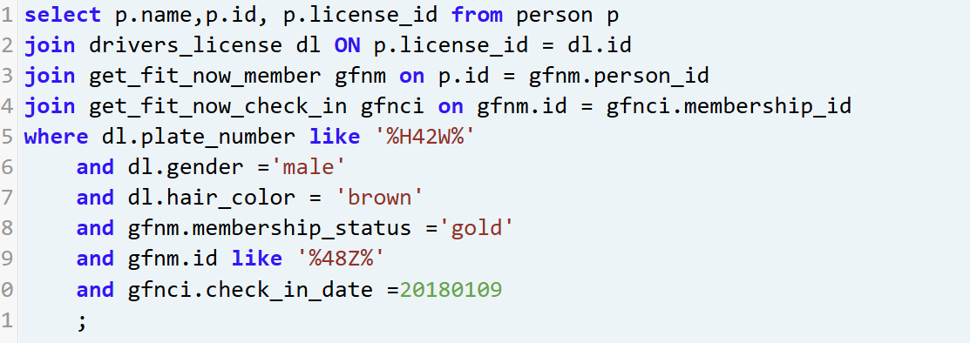
We got the result as
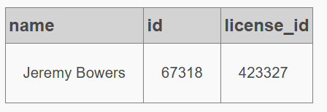

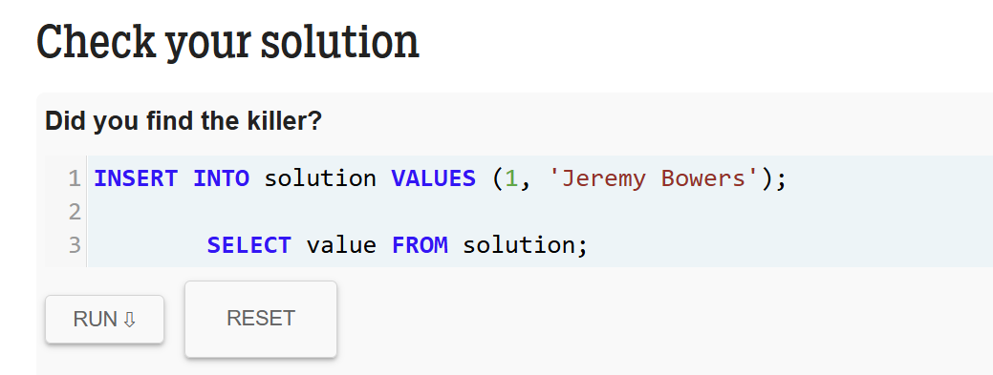
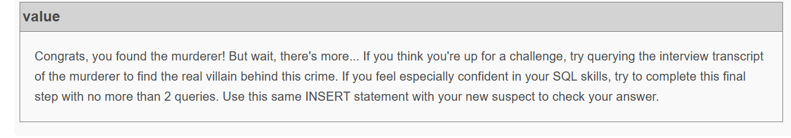
To find out Jeremy Bowers transcript
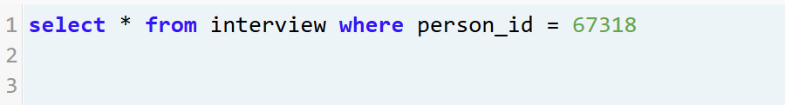
Here is the result of the query
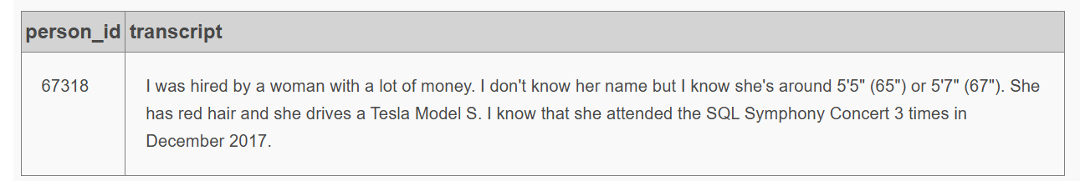
Based on the transcript, here is the SQL query
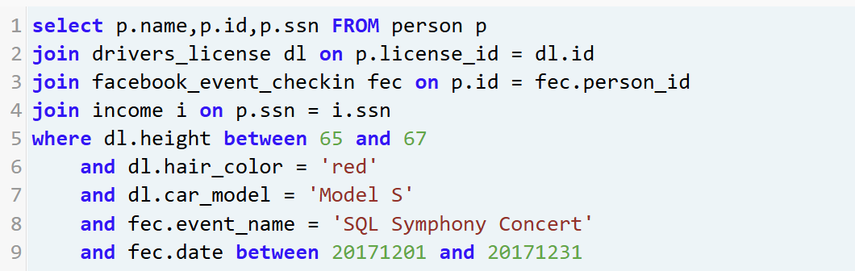

Result came 3 times – this match with Jeremy Bowers interview message.
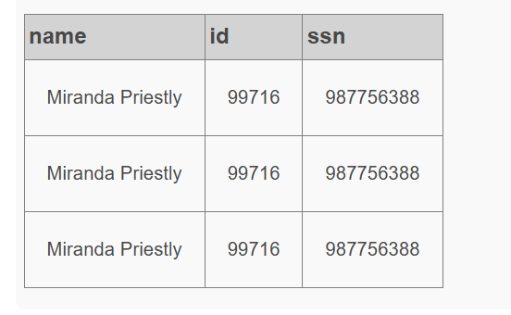
Now, let’s insert this solution to confirm if this assumption is correct

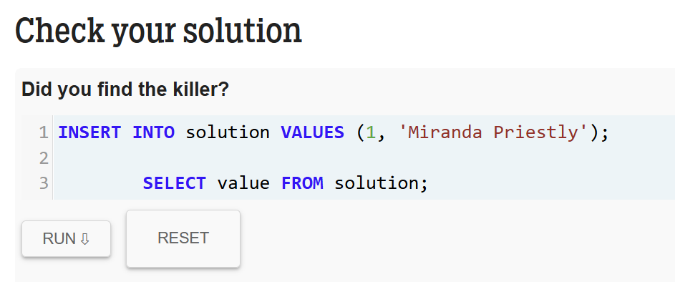

Result
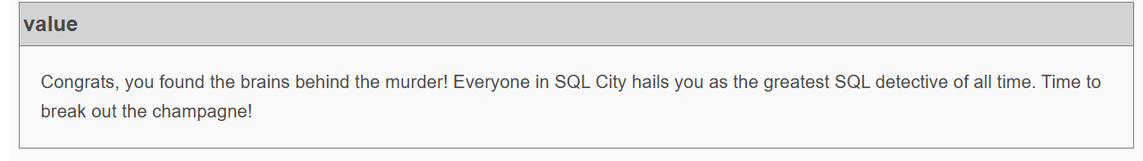

Reflection
Working through the SQL Murder Mystery helped me understand how real investigations reflect data analysis — both require following clues and connect information from multiple sources. Now, I am more confident in joining tables. I forgot to record my errors. But I learned how JOINs are essential for linking related tables, and that getting the ON clause wrong can silently break a query or return incorrect results. I also learned that connecting the correct columns are very important (Eg: used gfnm.id instead of gfnm.person_id and fec.id instead of fec.person_id). Overall, this project showed me that SQL is not just about syntax but about thinking logically and systematically to find answers hidden in data.

